**Adobe Express Add-on — Developer & User Documentation**

**User Guide :**

## **AI Marketing Content Generator – User Guide**

## **AI Looker Analyzer – User Guide**

## **Technical Requirements**

## **Solution 1: Adobe Express AI Content Studio (ContentGenius)**

## **Solution 2: Marketing Performance Analyzer (AI Looker Analyzer)**

## **✨ AI Marketing Content Generator – User Guide**

### **Step 1: Open Adobe Express Add-on Console**

Navigate to [Adobe Express Developer Console](https://developer.adobe.com/express/add-ons/) and open the project environment.

### **Step 2: Import Add-on Code**

Clone or download the GitHub repository and upload the HTML, CSS, iframe.js, and document.js into the Adobe Express Add-on tabs.

### **Step 3: Launch the Add-on**

Run the Add-on in **Preview Mode** from the Adobe Console.

### **Step 4: Describe Your Campaign**

In the **"Campaign Description"** box, enter your message.  
 Example:

“Launching eco-friendly sneakers”

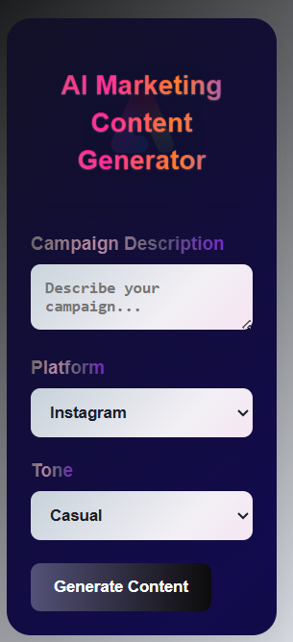

### **Step 5: Select Platform and Tone**

Choose your target platform (Instagram, Twitter, LinkedIn) and a tone (Casual, Formal, Bold).

### **Step 6: Generate Content**

Click the **"Generate Content"** button to receive:

* Caption
* Hashtags
* Call to Action

*Result appears below in seconds.*

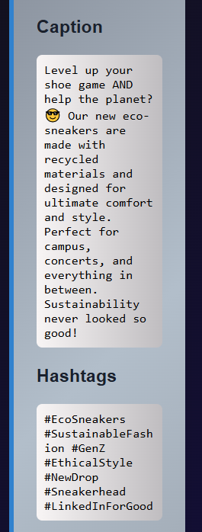

### **Step 7: Insert into Adobe Express Canvas**

1. In your Adobe Express design, first **insert a text box** (“Add your text”).
2. In the add-on, click the **📋 Copy** button.
3. Paste the copied content directly into your Adobe Express design.

*Optional: You can also click ➕ "Insert" (if supported) to place content into the canvas automatically.*

## **AI Looker Analyzer – User Guide**

### **Step 1: Upload Marketing Data File**

Click **"Choose File"** in the analyzer section and upload a CSV or Excel file containing your campaign performance data (e.g., likes, shares, CTR).

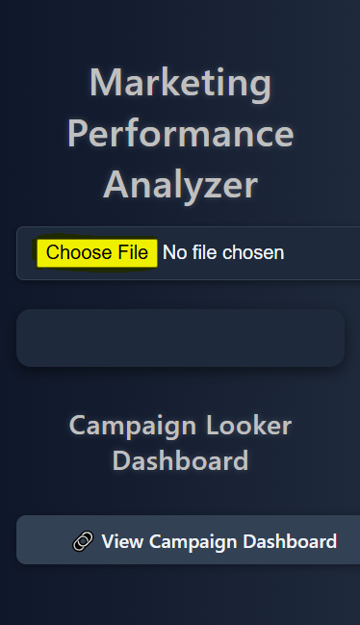

### **Step 2: View Analytics with Looker Studio**

The dashboard automatically visualizes your metrics using **Google Looker Studio**, embedded inside the Add-on.

* 📈 Impressions
* 💬 Engagement
* 🧲 CTR (Click-through Rate)

### **Step 3: Get AI Marketing Suggestions**

The AI generates tailored suggestions based on the campaign data:

Content improvement tips

Suggested timing

Best-performing formats

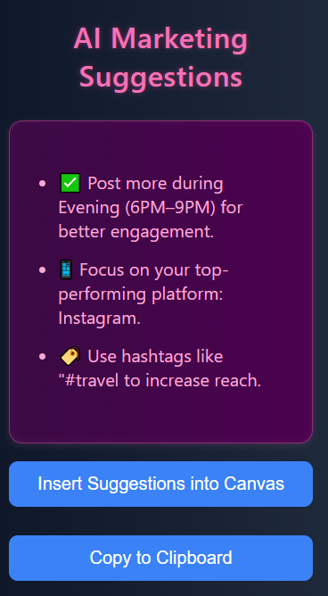

### **Step 4: Copy Insights to Clipboard**

Click **📋 Copy** to reuse the insights in your campaign plan or report.

## **Technical Requirements**

## **Solution 1: Adobe Express AI Content Studio (ContentGenius)**

### **Prerequisites to Run ContentGenius Add-on**

This add-on uses Google's **Gemini 2.0 Flash** API to generate platform-specific marketing content like captions, hashtags, and CTAs — directly inside Adobe Express.

**1. Set Up Gemini API Key**

**For instant results or testing:**

* Visit: https://aistudio.google.com/app/apikey
* Click **Create API Key and** Copy the API key
* **Open the** [**ifram.js**](http://ifram.js) **file which give in Folder**
* Search for const response = await fetch("https://generativelanguage.googleapis.com/v1beta/models/gemini-2.0-flash:generateContent?key=YOUR_API_KEY_HERE", {
* Put your API key place of YOUR_API_KEY_HERE
* Copy the key and replace the following placeholder inside iframe.js

**Note (for production use):** For a secure setup:

* Go to console.cloud.google.com
* Create a new project
* Enable **Generative Language API**
* Go to **APIs & Services > Credentials > API Keys**
* Generate and restrict your key
* Secure it via **backend proxy** instead of exposing it in frontend JS

### **2. Adobe Express Developer Console Setup**

* Open [Adobe Express Add-on Developer Console](https://developer.adobe.com/express/add-ons/)
* Create a new Add-on
* Upload the required files:  
  + index.html
  + styles.css
  + iframe.js
  + document.js
* Use the **Preview** option to test:  
  + Full AI-powered content generation
  + Copy to clipboard
  + Canvas text insertion

### **3. Internet Access**

Ensure your environment has active internet access to reach Google Gemini API endpoints.

### **4. Use a Modern Browser**

Use the latest version of **Chrome** or **Microsoft Edge** for optimal compatibility and SDK performance.

## **Solution 2: Marketing Performance Analyzer (AI Looker Analyzer)**

### **Prerequisites to Run Analyzer Add-on**

This Add-on helps visualize campaign metrics and provide AI-based suggestions for optimization using embedded Looker dashboards.

### **1. Adobe Express Developer Console Setup**

* Open [Adobe Express Developer Console](https://developer.adobe.com/express/add-ons/)
* Create a new Add-on or reuse your workspace
* Upload:  
  + index.html
  + styles.css
  + [iframe.js](http://iframe.js)
  + document.js
* In the UI, use the provided sample file:  
  + campaign_metrics1.csv (included in the project folder)
  + Upload it using the **“Choose File”** input in the interface

### **2. Preview & Test**

* Click **Preview** in Adobe Console
* It will load:  
  + Embedded Looker Studio dashboard
  + File upload analyzer
  + AI-generated marketing suggestions
  + Copy-to-clipboard functionality

**3. Internet Access**

Live visualization and AI tips depend on an active internet connection.

### **4. Use a Modern Browser**

Prefer **Chrome** or **Edge** for seamless iframe and analytics rendering.